House Interior design

General information

- Your name
- E-mail

Project information

- Designed area
  - All house/ apartment
  - Only part of the house / apartment (please specify)

- Area should be
  - Newly designed (no design exist; bare walls)
  - Redesigned (some design is already exist and you want to change it)

- In case of redesigning do you want to
  - Change existed design completely
  - Leave some part of existed design partially or completely unchanged (please specify)

- Total design budget
  - Least budget possible - Cost saving design is needed
  - Low budget – economical design
  - Mid budget – efficient design
  - High budget – lavish design
  - No restriction on budget – the design should be irrespective of budget

- Do you have layout/ area drawings of your house/ apartment / designed area?
  - Yes (please attach)
  - No

- Construction will be done
  - by owner
  - partly by owner
  - by contractor hired by owner
  - Any other – please specify

Occupants’ information

- Who are the people who will live in the house: relationship, names and ages

a) age

b) age

c) age

d) age

e) age

f) age

- What is most occupants’ (adults only) height?
  - Less than 160 cm
  - 160 – 180 cm
  - More than 180 cm

- What is most occupants’ (adults only) weight?
  - Less than 100 kg
  - More than 100 kg

- Do you have pets or expect to have pets?
  - Yes (please describe)
  - No

- What are occupant’s hobbies? (if you choose more than one, please rank)
  - Collecting (please specify)
  - Reading
  - Movies watching
  - Music listening
  - Music playing (please specify)
  - Cooking
  - Handmaid creativity: Crocheting; Knitting; Soapmaking; etc (please specify)
  - Drawing / painting
  - Woodworking
  - Vehicle Restoration (please specify)
  - Photography
  - Shopping
  - Singing
  - Dancing (please specify)
  - Gardening
  - Fishing
  - Cricket playing
  - Football playing
  - Basketball playing
  - Volleyball playing
  - Swimming
  - Biking
  - Cycling
  - Yoga
  - Fitness
  - Any other – please specify

- What is your favorite car? (if you choose more than one, please rank)
  - SUV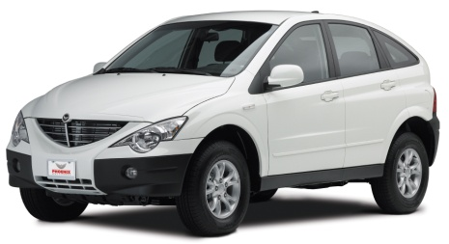 b) Sedan 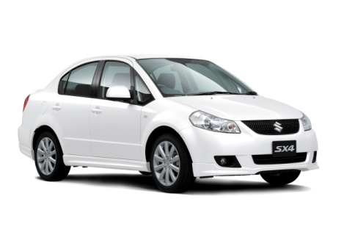c) Sports car 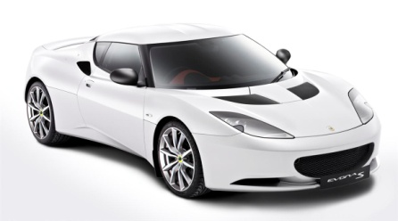

d) Hatchback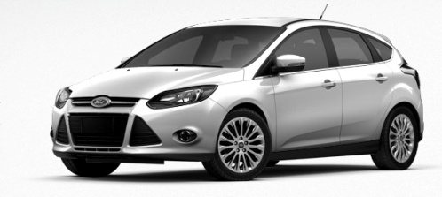e) Convertible 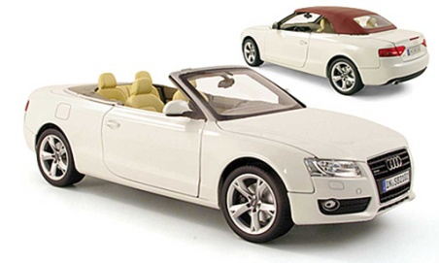 f) Van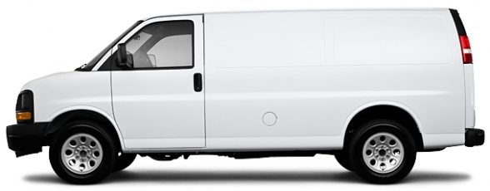 g)Any other – please specify

- How do you prefer to travel?
  - Agency organized journey
  - Self organized journey
  - Any other- please specify

- What do you like to do most during your holidays? (if you choose more than one, please rank)
  - Relax and unwind
  - Activities and sports
  - ‘nightlife
  - Visit museums/monuments/sites
  - Visit wildlife
  - Visit friends or family (location is not important)
  - Prefer a different holiday theme each time
  - Any other- please specify

- Which place do you prefer for picnic/ to sleep on the open grass lawn / park? (if you choose more than one, please rank)

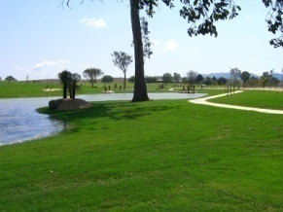
  - Close to the river/ road/ path
  - In a middle of the grass lawn
  - Under the tree
  - Depends on the non occupied bench location
  - Close to other park visitors
  - In a hidden corner
  - Any other please specify
  - Don’t like to have a rest on the open grass lawn / park

- In what kind of clothes do you feel most comfortable? (if you choose more than one, please rank)
  - Jeans
  - Suit
  - Home dress
  - Sport dress
  - Party wear
  - Beach wear
  - Any other- please specify

- What is the best gift for you? (if you choose more than one, please rank)
  - Useful gadget
  - Souvenir
  - Hand made
  - Jewelry
  - Alcohol / Food related
  - Something connected to my hobby
  - Money
  - Surprise gift
  - Other (please specify)

  - Cloudy
  - Sunny
  - Rainy
  - Windy
  - Snowy
  - Cold
  - Warm
  - Hot
  - Foggy
  - Any other – please specify

- How often do you have guests?
  - Once a year
  - Once in a few months
  - Every months

- What kind of food do you like?
  - Familiar food
  - Unusual food

- Do you like sunlight or dim light more?
  - Sunlight
  - Dim light
  - No preferences

- How often do you work at home?
- Always
- Often
- Sometimes
- Never

- Which 5 photos do you like the most?

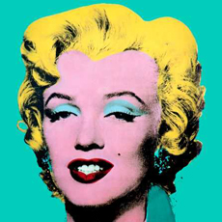 | 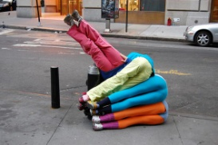 | 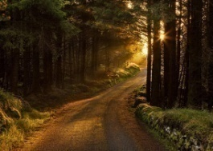 | 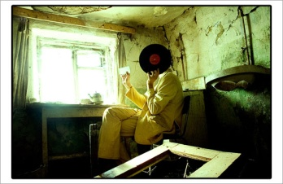 | 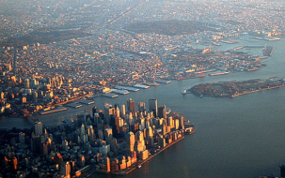
-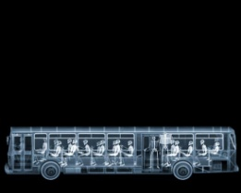 |  | 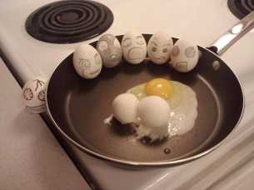 |  | 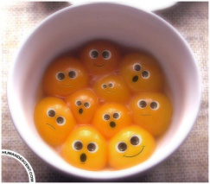
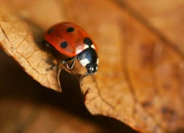 | 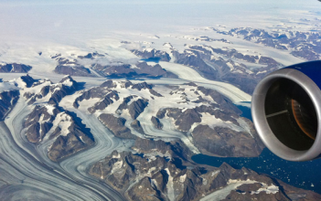 | 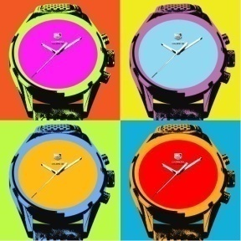 | 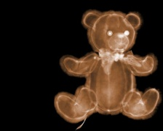 | 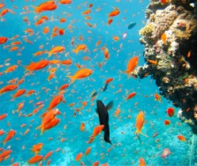
 | 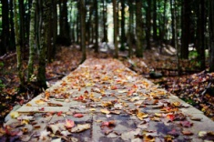 | 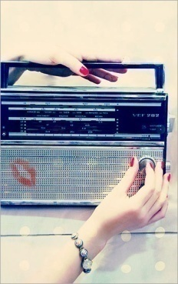 | 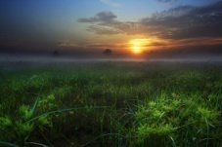
 | 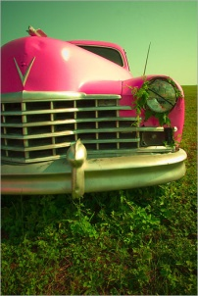 | 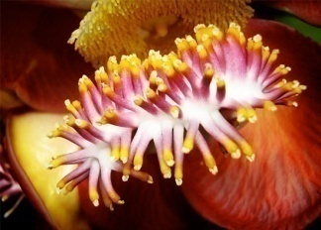 | 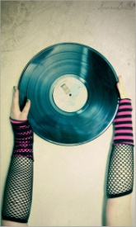 | 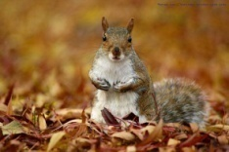

- Which 3 pictures do you like the most?

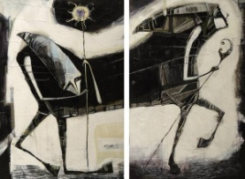 | - 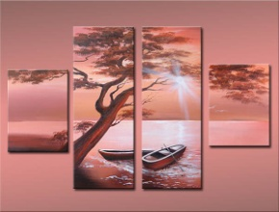http://art-assorty.ru/896-renaissance.html |  | - 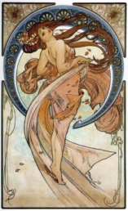
 | - 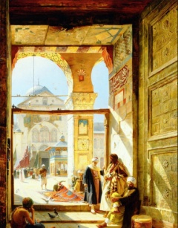 | - 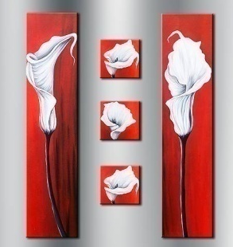 | - 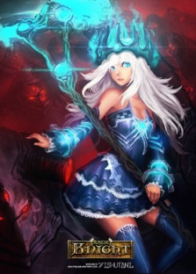
 | - 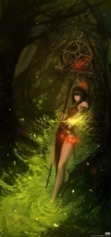 |  | - 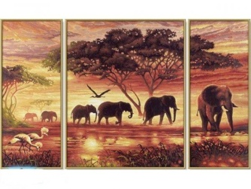
- 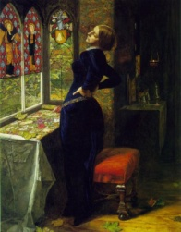 | - 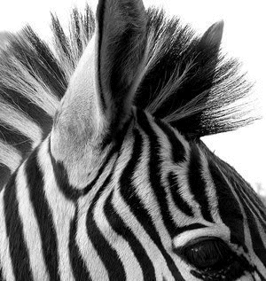 | - 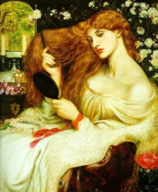 | - 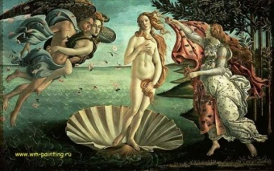
 | - 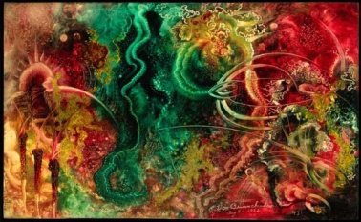 | - 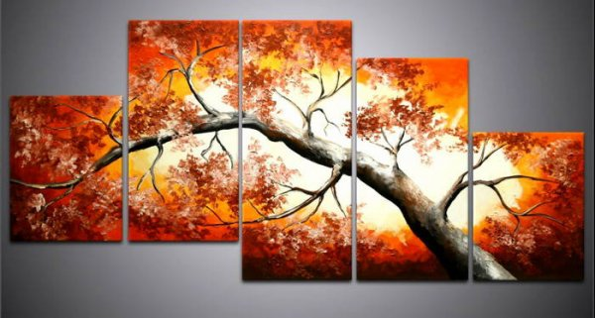 | - 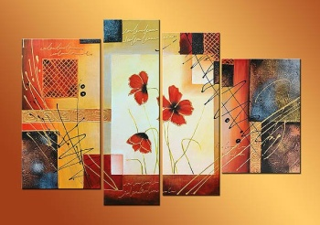
- 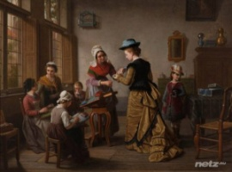 | - 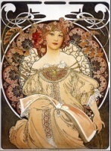 |  | - 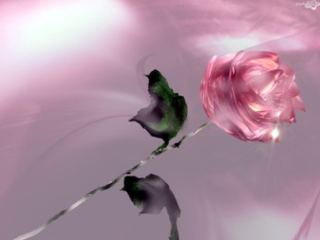

- Any extra information you would like to give us?

Design preferences

- What does your home mean to you (list all which apply in order of preference)
Prestige
Aesthetics
Conformity
Non-conformity
Security
Independence
Comfort
Nature
Privacy
Sociability
Leisure
Achievement
Family ties
Economy
Serenity
Convenience
Eccentricity

- Do you have a floor plan or design you are starting with?
  - Yes (please attach)
  - No

- Is there anything particular that you have seen in a house design or in someone else's house that you like?
  - Yes (please attach photos)
No

- Is there a particular design style that you prefer?
  - Yes (please attach photos)
  - No

- Is your style preferences same as your family members?
  - Yes
  - No

- If “no” which areas they might differ from you? Please provide as much information as possible.

- List the items which you presently own which you would like to have incorporated into the design? (please attach photos) :
  - Antiques
  - Furniture (other than antiques)
  - Carpet
  - Rugs
  - Paintings
  - Photography
  - Sculpture
  - Lighting fixtures
  - Appliances
  - Linens
  - Trophies
  - Other mementoes

- Any extra information you would like to give us?

Thank you for your time!

